**X. EFFECTS OF WEATHER MEASURES ON SUICIDE RATES – GLOBAL STUDY**

Some studies have been centered around the effects of weather metrics, such as temperate, wind, sunshine on behavioural aspects of humans, including suicides1-5.

We found it interesting to compare our global dataset of suicide rates to weather metrics and see if there are some patterns that could be studied further.

The first step of this analysis is to find a reliable data set for weather, which was quite challenging given the vast amount of unstructured data and poor capture quality.

It was finally extracted from a slice of 2017 data of NSDC:

<https://www.ncdc.noaa.gov/data-access/land-based-station-data/land-based-datasets/global-historical-climatology-network-ghcn>

Low, High and Average temperatures per country were calculated from 34,854,601 data readings from stations across the globe (219 different countries) during that year. And those readings were used to further enrich the suicides data frame. **x.1 Average temperate and Suicide Rate in different countries**

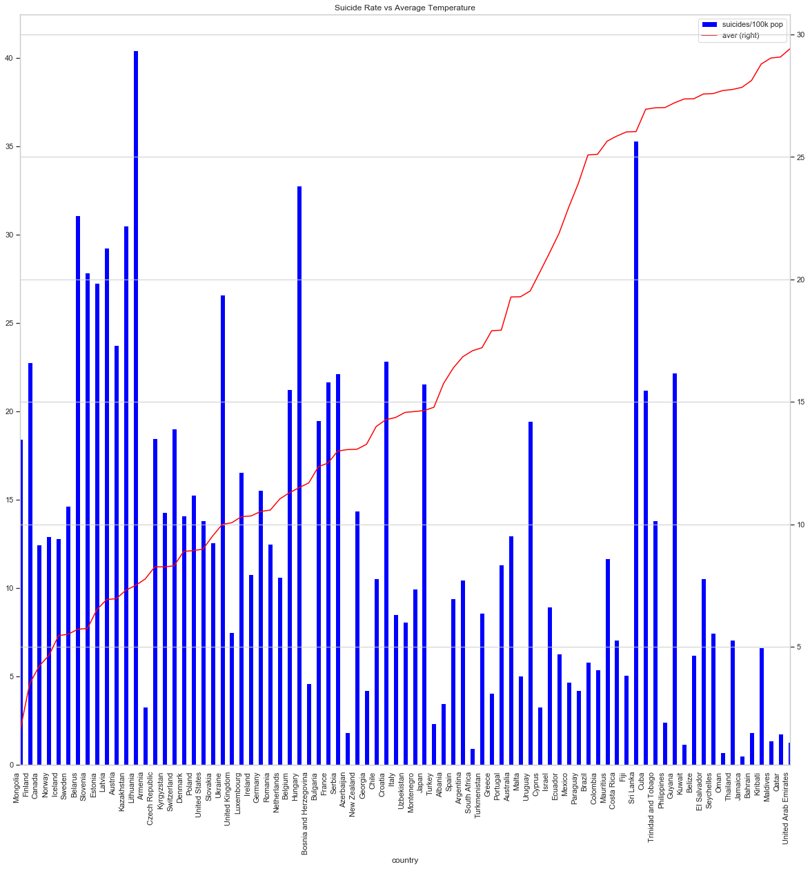

As shown in Figure x.1, there seems to be a relationship with the suicide rate by 100k population and the average temperate, it seems that the lower the average temperature, the higher the suicide rate.

It is relevant to point out that there are some countries which do not follow this pattern.

On the low temperate end of spectrum, Iceland, Sweden, Armenia, Switzerland, Denmark and UK have low suicide rates but still low temperatures, which would be interesting for a follow up study on how other variables can influence this, such as Sunshine, Wind, but also GDP per capita, as they are wealthy countries, where people can afford to travel and spend long periods of time in better weather regions.

On the other hand, there are some countries with high suicide rates and high average temperatures. It probably must be said that at some point this relationship seems to fear off, around the 15C average temperature, where bodies would comfortable.

**x.2 Correlation between Male and Female Suicides and Average Temperatures**

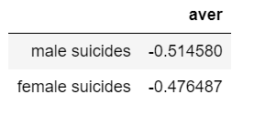

It is interesting to point out that females seem more resilient to temperature changes, and the correlation to suicide rates is lower.

**x.3 Correlation between Suicides and Maximum, Minimum and Average Temperatures**

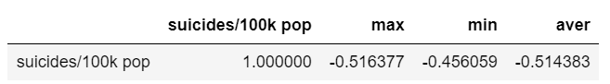

Correlation was calculated, as an average for all groups and ages, and it is the most significant when discussing average temperate, which makes sense given the extreme weathers some countries have.

Further analysis was done to see which age group is most vulnerable to this effect, and what group is most resilient.

Probably it is not surprising to see no relationship with temperate and suicide rates for kids (aged 5-14), where the data shows almost no correlation (-0.08), this correlation keeps growing with age plateauing at 55-75 age group, when it is the highest in the dataset (-0.54) .